
NCHE Breakout Session:
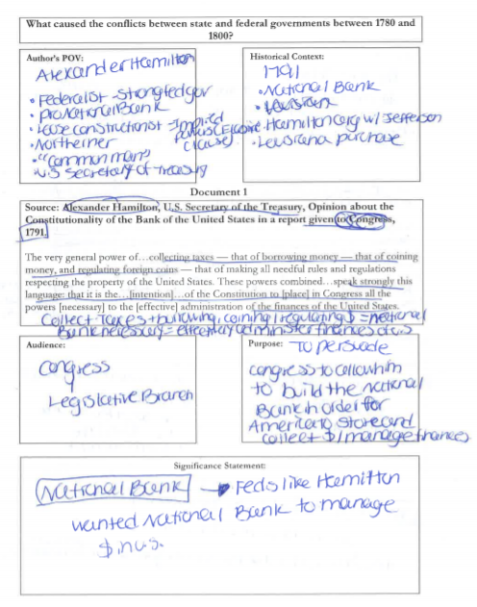
Four Corners Primary Source Analysis

Saturday, March 16, 2019
Washington, D.C.

Session Objectives:
TWBAT:
- Describe keys to exemplary Four Corners annotations.
- Practice completing Four Corners annotations on provided primary sources.
- Analyze how Four Corners annotations lead to strong written analysis.
- Practice responding to a DBQ prompt using Four Corners analysis.
See It: Why Four Corners?
Directions: Analyze the exemplar Four Corners annotations below. Then determine: What are the keys to exemplary Four Corners annotations? How will this impact written analysis of primary sources?

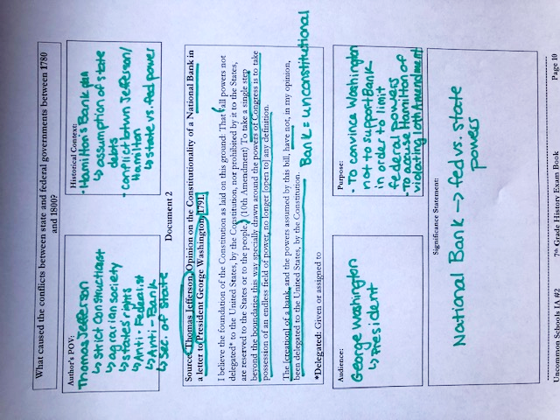

- What are the keys to exemplary Four Corners annotations?
____________________________________________________________________________________________________________________________________________________________________________________________________

- How will this impact written analysis of primary sources?
____________________________________________________________________________________________________________________________________________________________________________________________________

Keys to Four Corners Annotations:
Do It:
Directions: Actively read the prompt and then read the primary sources using Four Corners annotations.

What caused the conflicts between state and federal governments between 1780 and 1800?
Historical Context:
Author’s POV:

Document 3
Source: U.S. Congress, Sedition Act, 1798.

[I]f any person shall write, print, utter or publish…any false, scandalous (shocking) and malicious (hateful) writing or writings against the government of the United States, or either house of the Congress of the United States, or the President of the United States…or to stir up sedition (treason or rebellion) within the United States…or opposing or resisting any law of the United States…shall be punished by a fine… and by imprisonment not exceeding two years.

**AC:

Purpose:
Audience:

Significance Statement:

Key Takeaways about Four Corners:

What caused the conflicts between state and federal governments between 1780 and 1800?
Historical Context:
Author’s POV:

Document 4
Source: Virginia General Assembly, Virginia Resolution Pronouncing the Alien and Sedition Laws to be unconstitutional, and defining the rights of the states, 1798. (Written in secret by James Madison and Thomas Jefferson)

The General Assembly [does] particularly PROTEST against the…alarming infractions (violations) of the Constitution, in the two late cases of the "Alien and Sedition Acts," passed at the last session of Congress…

That this state having…ratified the Federal Constitution, expressly declared that…"the liberty of conscience and the press cannot be cancelled, abridged, restrained, or modified, by any authority of the United States”

**AC:

Purpose:
Audience:

Significance Statement:

Four Corners Core Idea:

See It: Impact on Student Writing
Directions: Read the exemplar paragraph below. Where do you see evidence of the Four Corners analysis in student writing?

Prompt: What caused the conflicts between state and federal governments between 1780 and 1800?

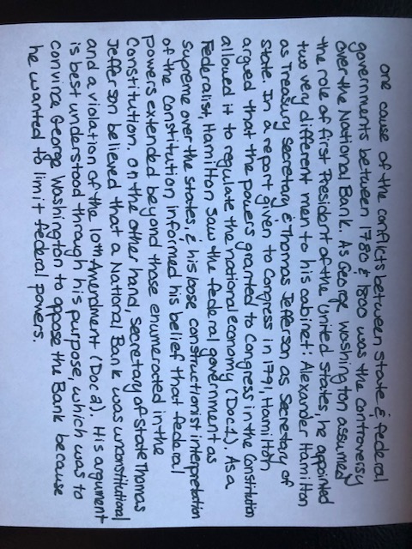

- Where do you see evidence of the Four Corners analysis in this student’s writing?
____________________________________________________________________________________________________________________________________________________________________________________________________

- What is the connection between strong Four Corners annotations and strong written analysis?
____________________________________________________________________________________________________________________________________________________________________________________________________

Core Idea:
Do It: Creating Your Written Analysis
Directions: Below is the beginning of a DBQ paragraph using the two documents that you used to practice Four Corners. Read the argument sentence and paraphrased evidence, then analyze each of your documents using the annotations from at least one of your corners. Potential sentence starters are included on page 9.

Prompt: What caused the conflicts between state and federal governments between 1780 and 1800?

Another cause of conflicts between the state and federal governments between 1780 and 1800 was the passing of the Alien and Sedition Acts. In 1798, John Adams and his Federalist Congress passed two acts, one of which was the Sedition Act. It established that talking poorly about any part of the federal government would result in punishment (Doc 3).
________________________________________________________________________________________________________________________________________________________________________________________________________________________________________________________________________________________________________________________________________________________________________________________________________________________________________________________________________________________________________________________________________________________________________________________________________________________________________________________________________________________________________________________________________________________________________________________________________________
The Alien and Sedition Acts were not well-received by all Americans. That same year, James Madison and Thomas Jefferson penned the Virginia and Kentucky Resolutions, which argued that the Alien and Sedition Acts were unconstitutional because they violated the First Amendment (Doc 4).
________________________________________________________________________________________________________________________________________________________________________________________________________________________________________________________________________________________________________________________________________________________________________________________________________________________________________________________________________________________________________________________________________________________________________________________________________________________________________________________________________________________________________________________________________________________________________________________________________________
Madison and Jefferson’s move set the precedent that states could nullify the Constitution, a dangerous reality that compelled John C. Calhoun to attempt the same political move in response to the Tariff of 1828. Ultimately, the controversy over the Alien and Sedition Acts not only demonstrates a single example of tensions between states and the federal government but paved the way for even larger national battles.

Reflections










For more information, including how to apply, please visit: www.uncommonschools.org

Name: _________________________________ Date: ____________________________
Resource Team:____________________________
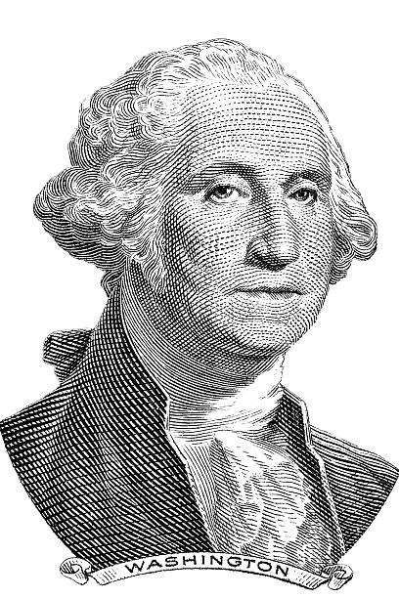
Four Corners Annotations
POV:
- What is the author’s name?
- Where is this person from?
- What is their role/job?
- What else do we know about this person that might help us to understand their perspective?

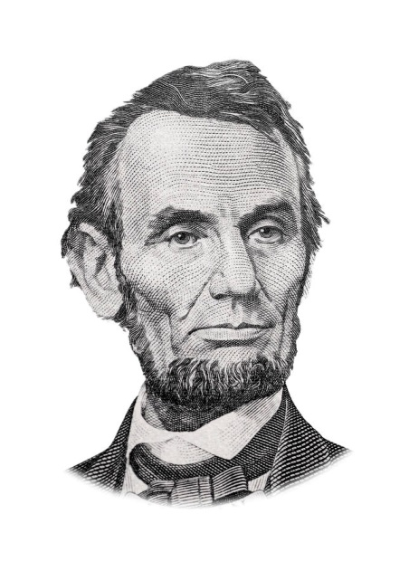
HC:
- What do we know about this topic?
- What else was going on at this time period?
- What key historical academic vocabulary can I box?

AUD:
- How does the type of source influence who would have read/heard/seen it?
- WHO would the author need to reach in order to achieve that action, even or change? (Revise/add after filling in AP)

AP:
- Why did this author use this type of source to communicate this message at this time to these people?
- What were the author’s motives, given what we know about the person and this time period?
- What specific actions, events, or changes did the author want to come about as a result of this speech/text?

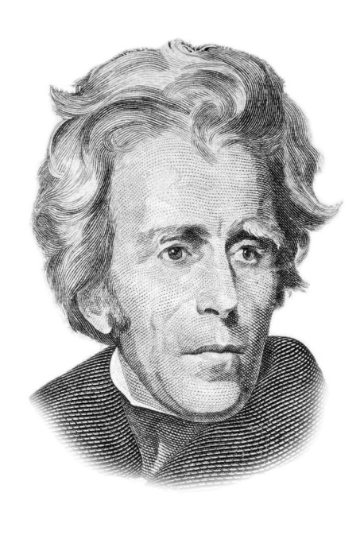

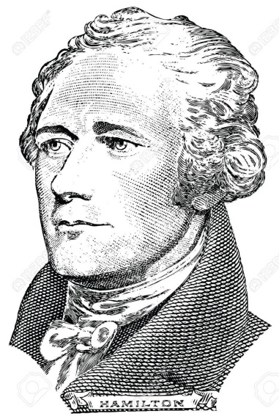

SIG:
- How does this document answer the prompt?
- How can I group this document with the others to make a strong argument?

Name: _________________________________ Date: ____________________________
Resource Team:____________________________

Resource: Analysis of Evidence

How to identify the best corner to analyze:
- In order to write a strong analysis, go back your paraphrased evidence and ask “HOW or WHY did the speaker (or artist, photographer, etc) do, say, or write what they did?”
- Scan your four corners and ask yourself “Which of the 4 corners helps me best answer the question of how or why?”
- The corner that best answers that question is the corner you should analyze.

How to write a strong ZO:
- Evidence analysis must clearly state which of the 4 corners is being used in the analysis and include the key information from that corner.
- Example: Jefferson’s argument is grounded in his point of view as a Southern Democratic-Republican. His world view was shaped by the fact that he believed in the importance of strong state governments and a limited central government.

Sentence Starters to name the corner:

POV | - As a <insert the title, noun, or adjective>, it makes sense that…  - <Insert author’s name>’s beliefs of <describe>influenced…
HC | - <State central idea of text or graph> is best understood within the context of the time period, as <insert info from historical context corner>  - At this time, <insert info from historical context corner>.
AUD | - This message was geared towards <name specific audience>, which…  - Since <Insert author’s name> was speaking to a largely <name specific audience>, the result was…
AP | - <Insert author’s name>’s purpose in arguing <restate author’s claim> was to…  - <Insert author’s name> intended to…  - By arguing that <restate author’s claim>, <Insert author’s name> desired to…

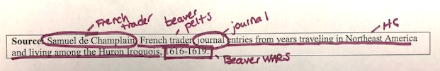
Marking up Source Lines
Step 4:
Identify the scope
Step 3:
Gather additional
Historical context
Step 2:
Determine
source type
Step 1:
Identify the
author

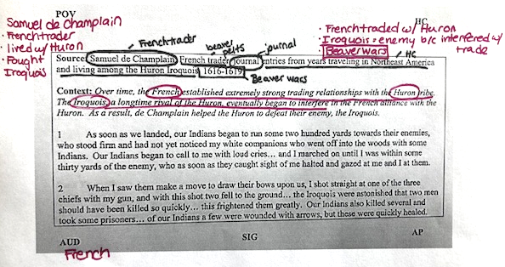
Sourcing Four Corners
Step 4:
Fill in AUD
Step 3:
Fill in HC
Step 2:
Fill in POV
Step 1:
Read context
(if provided)

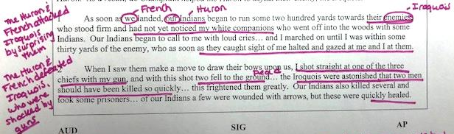
Reading for Author’s Claim
Step 3:
Paraphrase key lines to create AC annotations
Step 1:
Underline key lines of the argument
Step 2:
Clarify vague pronouns & key terms

AC vs. AP vs. SIG
AC | AP | SIG
author’s ARGUMENT  - What are the key lines?  - What is the author arguing in each paragraph?  - What is the author’s overall argument? | Author’s  motive  - Why did this author use this type of source to communicate this message at this time to these people?  - What were the author’s motives, given POV, AUD & HC? | Answer  The prompt  - How does this document answer the prompt?  - How can I group this document with the others to make a strong argument?

