Reading: The Great Migration & Operation Bootstrap
Between the 1940s and 1960s, a massive movement of people occurred that changed the face of both Puerto Rico and the United States mainland. This period is known as the Great Migration. During these decades, hundreds of thousands of Puerto Ricans left their island homes to start new lives in cities like New York, Chicago, and Philadelphia.
Operation Bootstrap: A Plan for Change
In the late 1940s, the Puerto Rican government launched an ambitious economic plan called Operation Bootstrap (Operación Manos a la Obra). The goal was to modernize the island's economy. For centuries, Puerto Rico had relied on agriculture, with most people working on large farms growing sugar cane, coffee, and tobacco.
Operation Bootstrap aimed to shift the economy toward industrialization. The government offered tax incentives (lower taxes) to U.S. companies to encourage them to build factories on the island. The idea was that factories would provide more stable jobs and higher pay than farming.
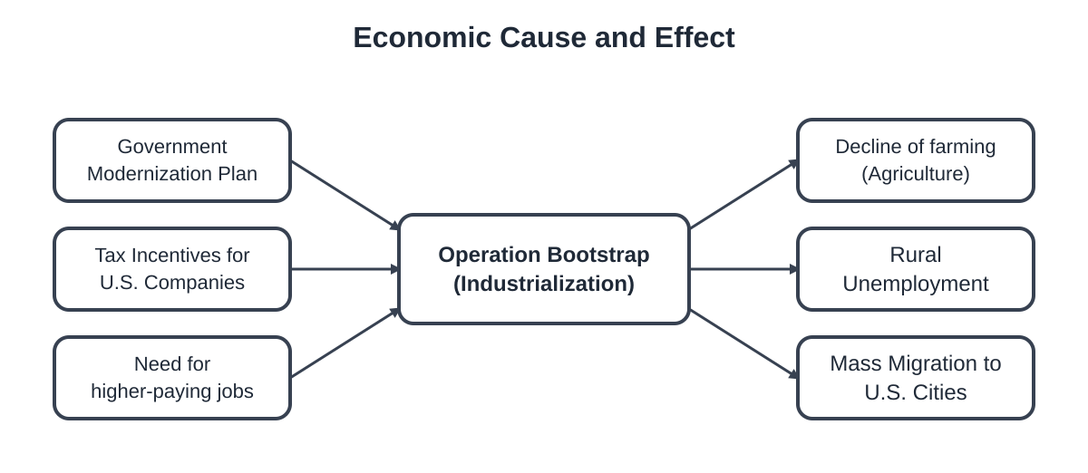
How the shift from farming to factories led to the Great Migration.
The Push and Pull of Migration
While Operation Bootstrap brought new factories, it also caused a major problem: displacement. As the island focused on industry, the agricultural sector collapsed. Small farmers could no longer make a living, and thousands of rural workers lost their jobs. This was a major push factor—a reason to leave.
At the same time, there were strong pull factors drawing people to the mainland. After World War II, U.S. factories in urban centers like New York City needed workers. Because Puerto Ricans are U.S. citizens, they could travel freely to the states. New, cheaper air travel made the journey possible for many families for the first time.

Check Your Understanding: Explain the 'paradox' of Operation Bootstrap. How did a plan meant to create jobs on the island end up causing so many people to leave?

Vocabulary Matching
Directions: Review the key terms below. These words help us understand why and how people moved from Puerto Rico to the United States mainland. Match each term to its definition and visual representation.

Term | Visual Clue | Definition
1. Diaspora | A map showing arrows spreading out from one island to many different cities.
2. Migration | A suitcase and a plane ticket showing a one-way trip to a new home.
3. Industrialization | A large factory icon with smoke stacks and gears turning.
4. Rural | A quiet landscape with green mountains, palm trees, and small farms.
5. Urban | A busy city skyline with tall buildings, subways, and crowded streets.

Definition Bank: Write the correct letter in the boxes above, or write out the full definition.
A. The process of changing an economy from farming (agriculture) to manufacturing and factories.
B. A population that has been scattered away from their original homeland but stays connected to their culture.
C. Relating to the countryside, farming, or agriculture rather than the city.
D. The movement of people from one place to another to live or work.
E. Relating to a city or town with a high population density.

Check Your Understanding: Use two of the vocabulary words above in a single sentence describing the Puerto Rican experience in the 1950s.
During the 1950s, many people moved from...

Notice and Wonder: Bomba Dancers
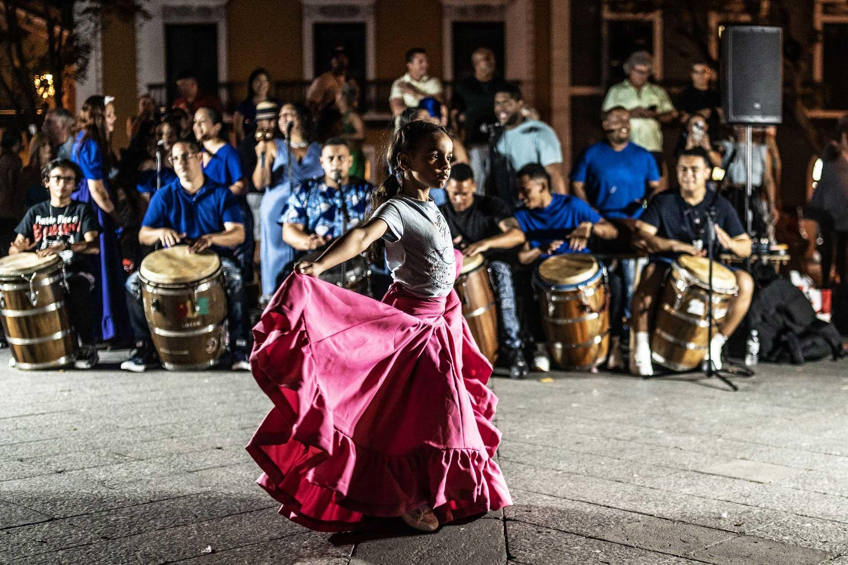
Bomba is a traditional Afro-Puerto Rican dance and musical style that involves a rhythmic dialogue between the dancer and the drummer.
Image Description: In this photograph, a group of dancers wears long, flowing white skirts with colorful accents. They move in a circle around drummers playing large wooden barrels called barriles. One dancer stands in front of the lead drummer, snapping her skirt to create a rhythmic challenge that the drummer must follow with his beats.

1. SEE | 2. THINK | 3. WONDER
What specific details do you notice in the image? (Colors, instruments, movements, clothing) | What does this tell you about Puerto Rican culture or the history of the people who created this music? | What questions do you have about this tradition or how it survived the migration to the mainland?

Reflection: Bomba was created by enslaved Africans on Puerto Rico's sugar plantations as a way to communicate and resist oppression. Why do you think this dance remains a powerful symbol for the Puerto Rican diaspora living in cities like New York today?

Causes and Effects of Migration
During the mid-20th century, Puerto Rico underwent a massive economic transformation. This shift, combined with new opportunities on the U.S. mainland, created a movement of people known as the Great Migration. Use what you have learned about Operation Bootstrap and the shift from agriculture to industrialization to complete the graphic organizer below.
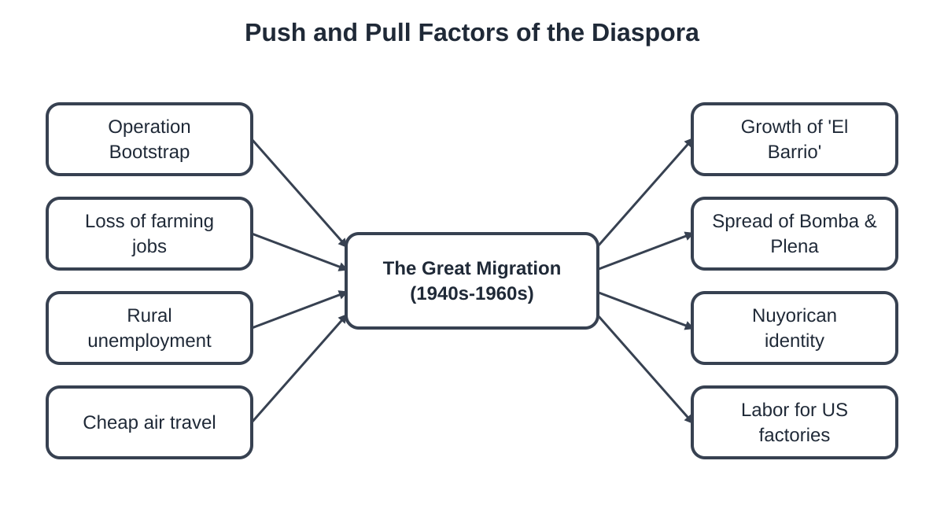
This map shows the 'Push' factors (causes) that led people to leave the island and the 'Pull' factors (effects) of their arrival on the mainland.
1. The Push: Economic Displacement
Explain how the shift from agriculture (sugar and coffee) to industrialization (factories) acted as a 'push factor.' Why couldn't rural workers simply stay on their farms?

2. The Pull: Life in the Mainland Cities
When Puerto Ricans arrived in cities like New York, they formed vibrant communities called 'enclaves.' How did these communities help preserve Puerto Rican culture while also creating something new (like Salsa music)?

3. Critical Thinking: The Paradox
Operation Bootstrap was designed to help Puerto Rico's economy grow. Why is it considered a 'paradox' that a plan meant to improve the island actually caused hundreds of thousands of people to leave it?

Social Media: 1950s NYC
🏙️ From the Island to the City
Imagine you are a young person who has just moved from a rural farm in Puerto Rico to the bustling streets of New York City in 1955. Your life has changed from the quiet agricultural fields of the island to the loud, crowded, and exciting environment of El Barrio (Spanish Harlem).
Your Task: Design a social media post (like Instagram or TikTok) to share your first impressions with your friends and family back home. Use the template below to create your post.
📸 Photo Box: In the space below, describe or sketch a 'photo' that captures your new life in NYC. Think about the tall buildings, the subway, the winter coats, or the music in the streets.
[Draw or describe your photo here...]

✍️ Caption: Write a caption describing your first impressions. How is the city different from your farm back home? What do you miss? What are you excited about?
#️⃣ Hashtags: Create 3 relevant hashtags for your post (e.g., #NewLife, #Boricua, #NYC).

Reflect: Why did so many people from rural Puerto Rico feel 'displaced' during this time? How does your social media post reflect the shift from a rural to an urban lifestyle?

