Zaire '74 and the World Stage

The Shake and the Beat
In 1974, everyone watched Kinshasa, Zaire (which is now called the Democratic Republic of the Congo). The biggest event was the 'Rumble in the Jungle,' a famous boxing match for the heavyweight championship between Muhammad Ali and George Foreman. But there was also Zaire '74, a huge three-day music festival. It was made to show the connections between people from Africa and people of African heritage around the world.
This festival was very important for Pan-Africanism. This is the belief that people of African descent have a shared past and should work together to help each other. The festival brought together famous African musicians like Miriam Makeba and Manu Dibango with American stars like James Brown and B.B. King. For many performers, it felt like coming home to the land of their ancestors. It helped close the distance created by the Diaspora, which means people spreading out from their original homeland.

Black and Latino Unity: 'My People'
One of the best parts of the festival was when the Fania All-Stars played. This group was super famous in the New York salsa music scene. Their leader, Héctor Lavoe, was a legend, and they performed a song called 'Mi Gente' (My People). Even though the words were in Spanish, everyone understood the message of Cultural Solidarity.
When Lavoe sang to 80,000 African people, it showed how much African culture was a part of Latino music and who they were. It proved that fighting for respect and being seen wasn't just for Black people or Latino people in the United States. It was a worldwide movement that brought people together, even across the Atlantic Ocean.

The Rainbow Coalition: Working Together
While Zaire '74 showed unity around the world, similar groups were coming together in the United States. A great example of this was the Rainbow Coalition. Fred Hampton of the Black Panthers started this group in Chicago. This team brought together groups that many people thought would never cooperate: the Black Panthers, the Young Lords (a group of Puerto Rican activists), and the American Indian Movement (AIM).
These groups understood they all faced the same big problems, like not having enough money and unfair treatment from the police. By working together, they were like the Pan-African movement. They looked past their own ethnic backgrounds to create a strong team fighting for fairness. Just as 'Mi Gente' was important in an African stadium, the Rainbow Coalition showed that groups facing challenges were stronger when they saw their local problems as part of a bigger, shared human experience.
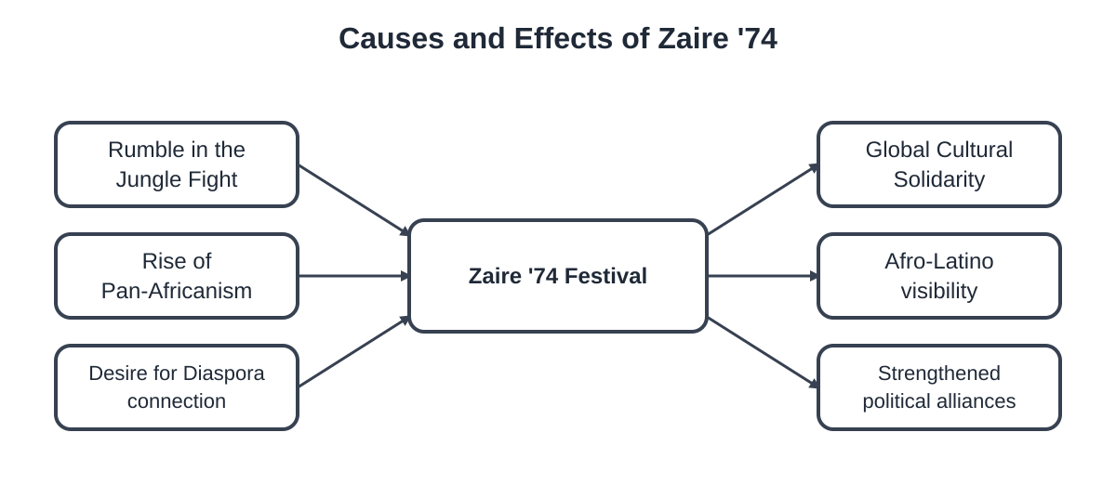
See how the Zaire '74 festival connected different groups. (for teachers)
Lyric Analysis: 'Mi Gente' by Fania All-Stars

Context: In 1974, the Fania All-Stars played 'Mi Gente' at the Zaire '74 music festival in Kinshasa. Héctor Lavoe sang this song, which connected the Spanish-speaking Caribbean and Africa. Read the main song words below.
'My People' (Selected Lyrics)
Spanish Lyrics:
Mi gente, ¡ustedes!
Lo más grande de este mundo
Siempre me hacen sentir
Un orgullo profundo
Oye, mi gente
Canten conmigo
Que en la unión está la fuerza
De nuestro destino
English Translation:
My people, you!
The best part of this world
You always make me feel
Very proud
Hey, my people
Sing with me
Because being together makes us strong
For our future

1. What 'Mi Gente' Means: When Héctor Lavoe first sang "Mi Gente" in New York, it was for Puerto Ricans and other Latinos. But at the Zaire '74 show, he sang it to 80,000 Africans. How did the song's meaning of "My People" grow or change in this new place?

2. Cultural Teamwork: The song says, "In unity lies the strength." How does this idea connect to the goals of Pan-Africanism and the Rainbow Coalition you read about earlier?
3. Anthem of Pride: Why is the phrase 'Lo más grande de este mundo' (The greatest thing in this world) a strong message for people in the Diaspora who have faced unfair treatment and being left out?

Personal Reflection: Imagine you are a singer like Héctor Lavoe. You travel from New York to Africa to sing for the first time. Think about how it would feel to sing a song called 'My People' to a crowd that shares your family's history but speaks a different language. How does this show that music can be very powerful in bringing people together all over the world?

Comparing Revolutions

The Rainbow Coalition: Looking at Problems at Home & Helping Others Worldwide
How We Work Together | Main Goals | Community Programs (like Breakfast Programs) | Links to Pan-Africanism / World Unity
Black Panther Party (BPP)
Young Lords Organization (YLO)
American Indian Movement (AIM)

Compare and Contrast: Black Panthers vs. Young Lords (for teachers)
Use the Double Bubble Map below to show what was special about each group and what they believed in together as part of the Rainbow Coalition.
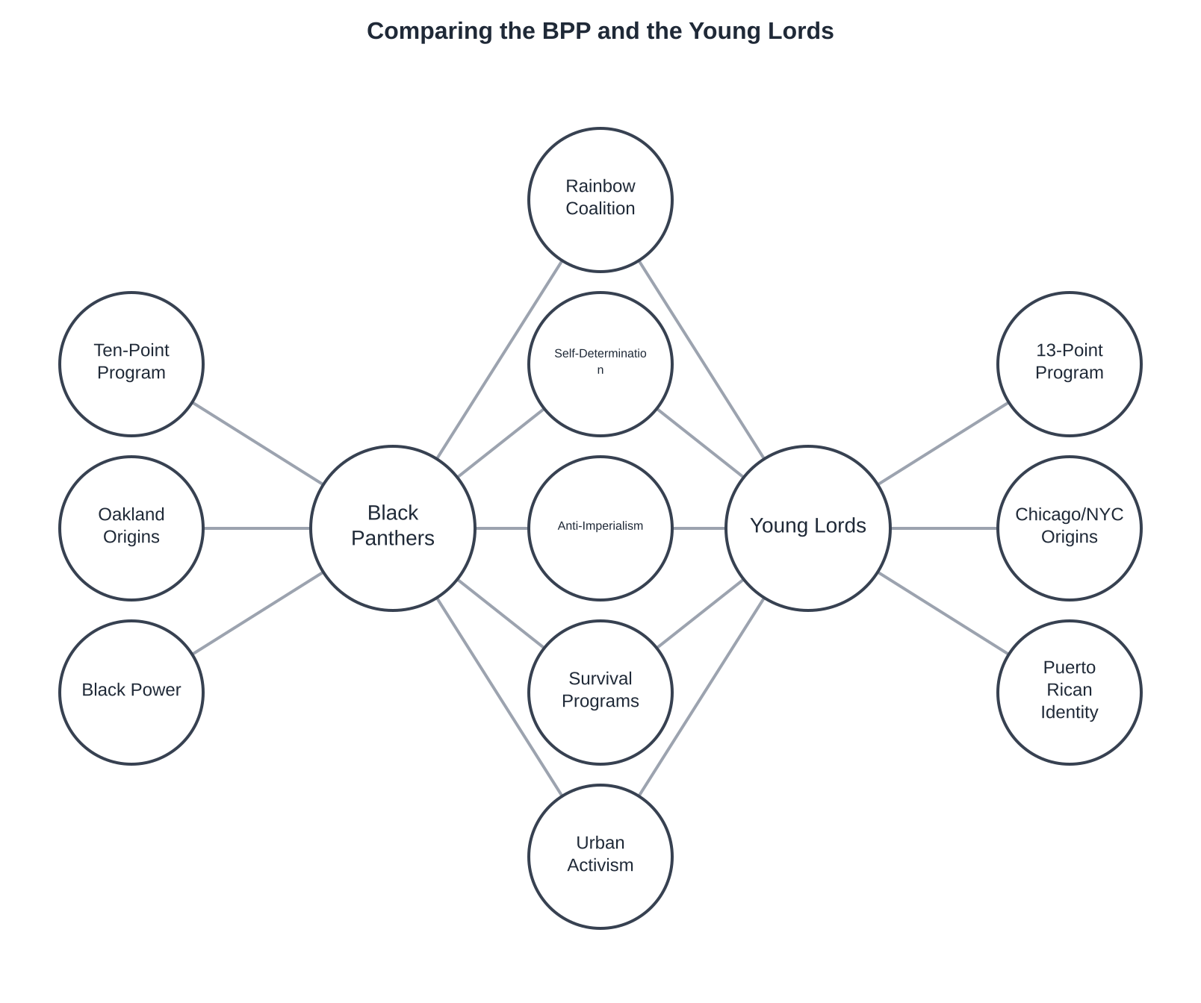
A side-by-side look at two important groups from the first Rainbow Coalition.

Final Synthesis Prompt:
How did music like Fania All-Stars' 'Mi Gente' and groups like the Rainbow Coalition help people who felt left out see their local problems as part of a worldwide fight?
Draft your short essay below:
Cultural solidarity and Pan-Africanism linked people across borders and languages.
One way music like 'Mi Gente' brought people together was...
Also, the Rainbow Coalition proved the Young Lords and Black Panthers were alike because...
These links helped people understand their local problems were part of bigger, worldwide issues because...

