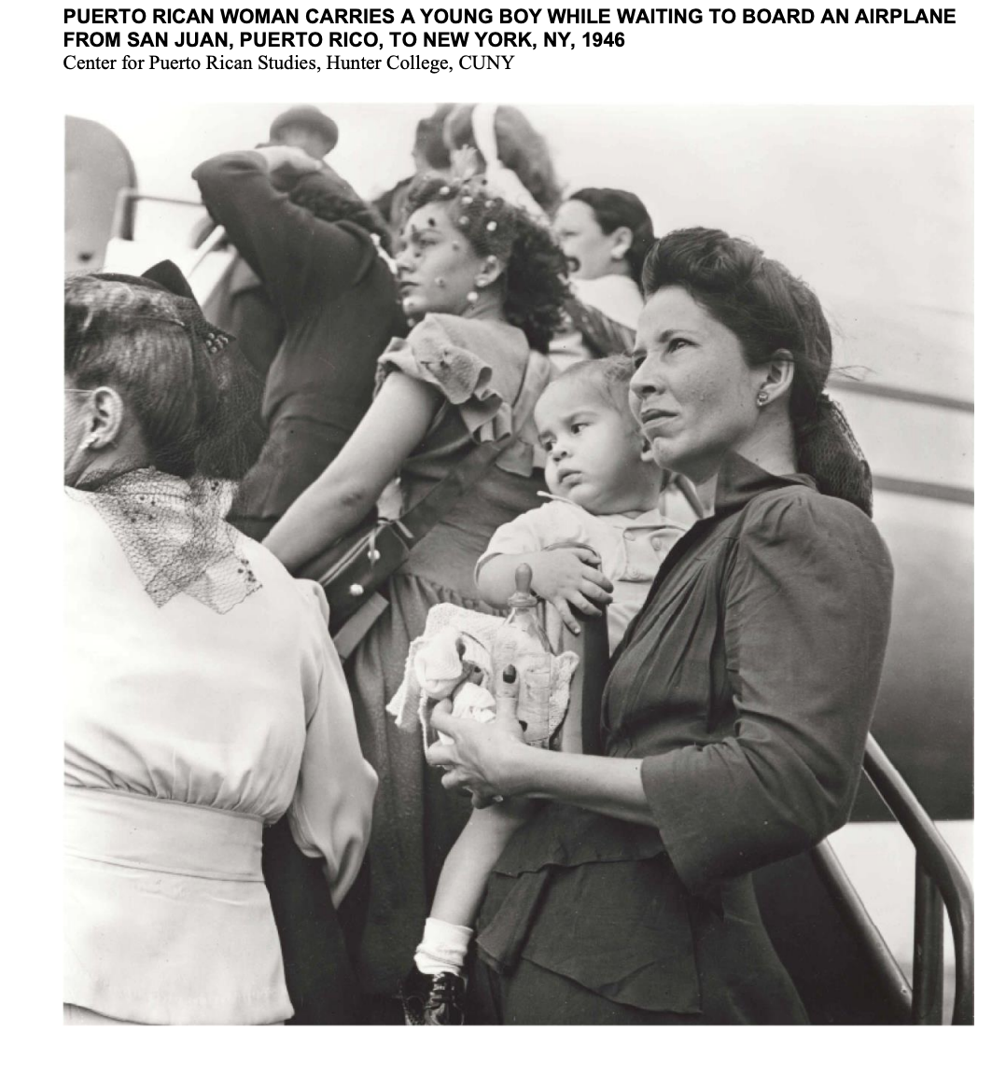

Identify what you see in the image.
Describe the main figure in this photograph. How is she dressed? What expression is on her face? What about the child she carries?
What do you think the photographer meant to convey by framing the scene in this way?
What do you think this woman might have experienced when she arrived in New York?

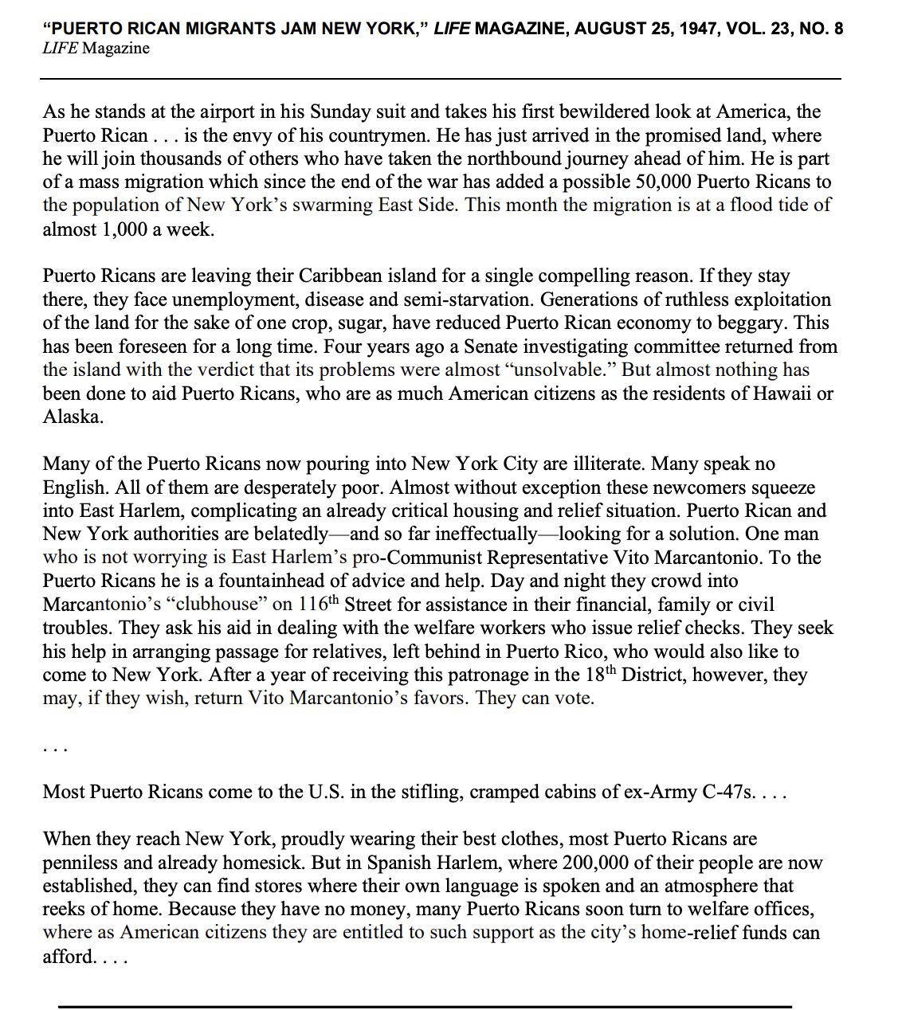

Complete the following SOAPSTONE Analysis of this article:
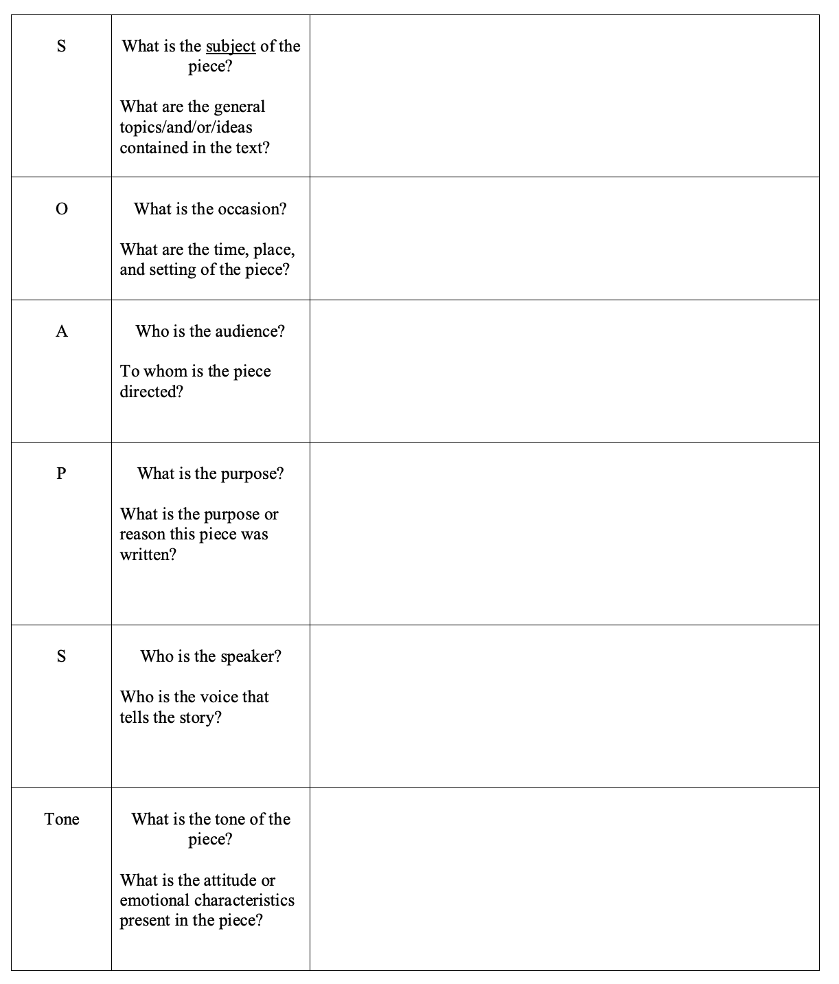

Additional Questions:
- According to the LIFE magazine article, why are Puerto Ricans leaving the island in such large numbers?

- According to LIFE, what experiences are shared by those who are newly arrived in New York City?

- Based on what you have read in the article, who do you imagine the writer and reader(s) to be? Why is that significant?

- Is this a purely informational article? Do you detect any kind of bias? If so, where? Provide specific examples from the text.

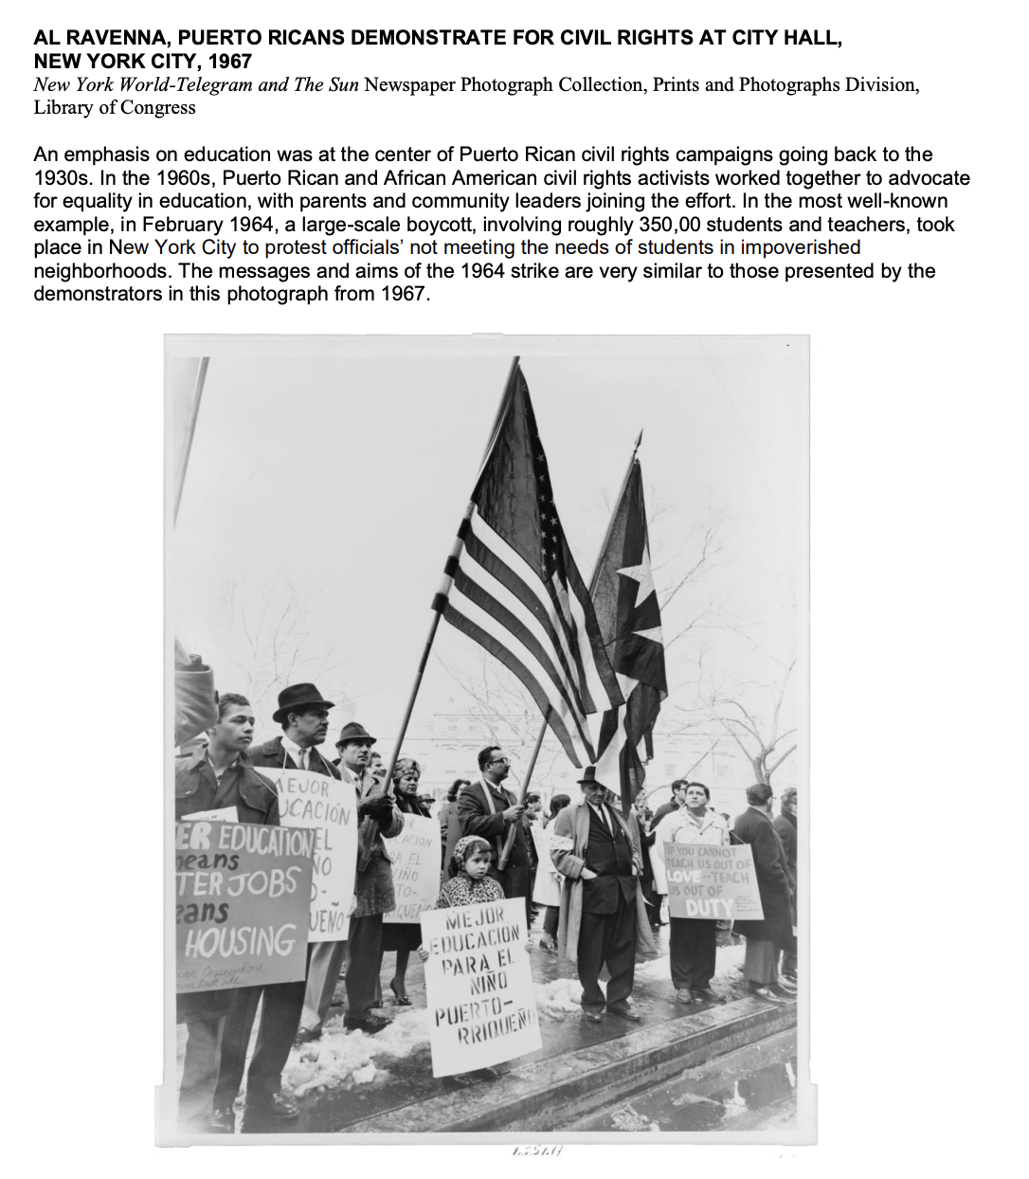

Answer the following questions:
- Describe the scene in the photograph. What figures or elements of its composition do you find particularly striking?

- What two flags are the Puerto Rican demonstrators holding up? What effect might that have on the viewer?

- Based on what you see, what do you think these Puerto Rican demonstrators were trying to accomplish? What details support your assessment?

References:
Puerto Rican Migration

