Station 1: The Waves of Migration

Puerto Rico's relationship with the United States has created unique patterns of movement. Unlike other Caribbean migrants, Puerto Ricans are U.S. citizens, yet their migration has been deeply influenced by economic policies, colonial history, and natural disasters. Use the timeline below to analyze the 'Push' and 'Pull' factors of each era.

Timeline of Puerto Rican Migration
Era | Push Factors (Why leave the island?) | Pull Factors (Why move to the mainland?)
1800s
Early Presence
Early 1900s
Before WWII
1940s–1960s
Operation Bootstrap
2000s–Present
Recent Waves

Primary Source Scaffolding: The 1953 Peak
In 1953, Puerto Rican migration reached a historic peak. Following World War II, the combination of cheap airfare and the industrialization program known as Operation Bootstrap changed the island's economy. While the program aimed to modernize Puerto Rico, it led to a sharp decline in agriculture (sugar and coffee), leaving many rural workers unemployed. At the same time, U.S. factories in cities like New York were actively recruiting labor.
Analysis Question: How did the 'Post-WWII Boom' create a 'perfect storm' for the 1953 migration peak? Use evidence from the text above regarding economic shifts and transportation.

Station 2: Economic Shifts & Operation Bootstrap

Vocabulary Word Wall (for ESL students)
Industrialization: The process of developing industries in a country or region on a wide scale, shifting from farming to manufacturing.
Tax Incentives: Reductions in taxes offered by a government to encourage companies to invest in a specific area or industry.
Displacement: The forced or necessary movement of people from their locality or environment (in this case, moving from rural farms to cities or the US mainland).

The Transition: From Agriculture to Industry
Before the mid-20th century, Puerto Rico's economy was dominated by agriculture, specifically sugar and coffee. In the 1940s, the government launched Operation Bootstrap (Operación Manos a la Obra). This ambitious plan aimed to modernize the island by attracting U.S. corporations through tax incentives and low labor costs.
While the program successfully built factories and increased the GDP, it had a secondary, unintended effect: it accelerated the decline of the agricultural sector. As small farms became less profitable, rural workers faced massive unemployment. This economic shift created a surplus of labor that the new factories could not fully absorb, leading to a paradox where industrialization actually fueled the 'Great Migration' to the U.S. mainland.

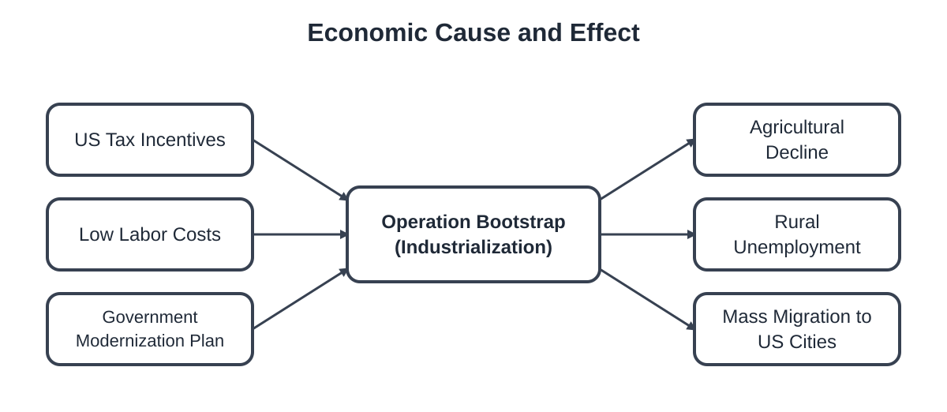

Analyze how the shift to industry impacted the population. ( for teachers)

1. Analysis: Explain the 'paradox' of Operation Bootstrap. How did a program designed to create jobs on the island result in nearly 500,000 people leaving for the U.S. mainland during the 1950s?

2. Comparison: How did the shift from sugar/coffee to factory work change the 'push factors' for Puerto Rican workers? Use the term 'displacement' in your answer.
3. AP Style: To what extent did U.S. economic policy treat Puerto Rico as a 'domestic' space versus a 'colonial' resource during the era of Operation Bootstrap? Provide evidence from the text regarding tax incentives or labor recruitment.

Station 3: Cultural Resistance through Bomba & Plena

Music in Puerto Rico has never just been about entertainment. For the Afro-Puerto Rican community, it has served as a powerful tool for survival, communication, and political expression. In this station, you will explore two foundational genres: Bomba and Plena.

Part 1: Comparing the Roots of Resistance
Use the descriptions below to complete the comparison table.
- Bomba: A vibrant Afro-Puerto Rican style born from the resilience of enslaved Africans. It served as a form of communication and resistance against oppression. It features a dialogue between a dancer and a drummer using barrel drums (barriles).
- Plena: An Afro-Puerto Rican genre born in the working-class barrios (neighborhoods) of Ponce around the turn of the 20th century. Often called the 'journal of the people,' it was used to spread news and social commentary.

Feature | Bomba | Plena
Origins
Primary Purpose
Key Elements
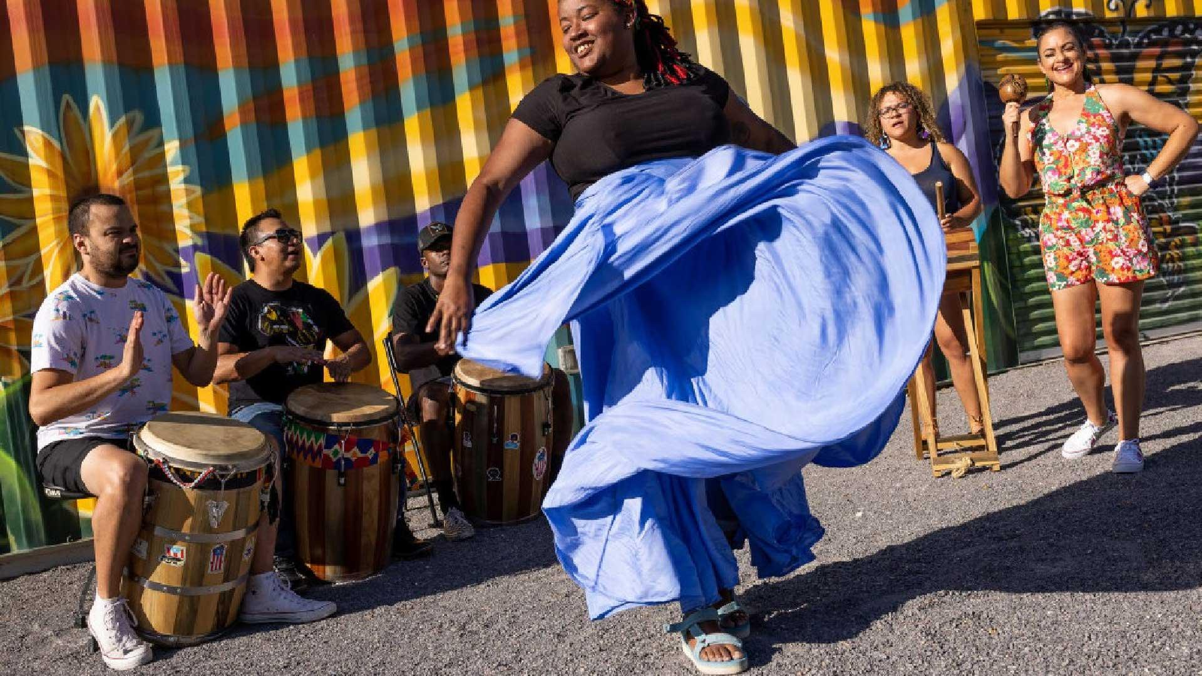
Bomba features a unique 'challenge' or dialogue between the dancer and the lead drummer.

Part 2: Music as a Cultural Weapon
During the 1950s, Puerto Rican protest music in the diaspora emerged as a cultural weapon for communities confronting racism, poverty, and colonialism. Artists used songs to affirm national identity and denounce U.S. colonial rule.

What do you NOTICE about how music was used by enslaved people (Bomba) vs. working-class urban residents (Plena)?
What do you WONDER about the role of music today in movements for social justice or identity?

Critical Thinking: Why might a colonial power or an oppressive system find music like Bomba or Plena threatening?

Station 4: The Nuyorican Sound & Global Reguetón

The Transnational Circuit: From El Barrio to the Underground
Music in the Puerto Rican diaspora is not just entertainment; it is a transnational circuit—a constant loop of ideas, rhythms, and people moving between the island and the mainland.
In the 1950s-70s, Salsa emerged in New York City's Caribbean enclaves like El Barrio (Spanish Harlem) and the South Bronx. It was a fusion of Cuban son, Puerto Rican plena, and mambo. While some lyrics were universal, many served as a 'cultural weapon' to express the struggles of racism, poverty, and colonialism faced by the Nuyorican community.
By the 1980s and 90s, a new sound began to crystallize in Puerto Rico's underground scene: Reguetón. This genre didn't start in a vacuum; it was built by the diaspora, blending Jamaican dancehall, U.S. hip-hop, and Afro-Latino rhythms. This music traveled through a circuit linking Panamá, Puerto Rico, Colombia, and New York, reflecting the shared youth experiences of marginalization.
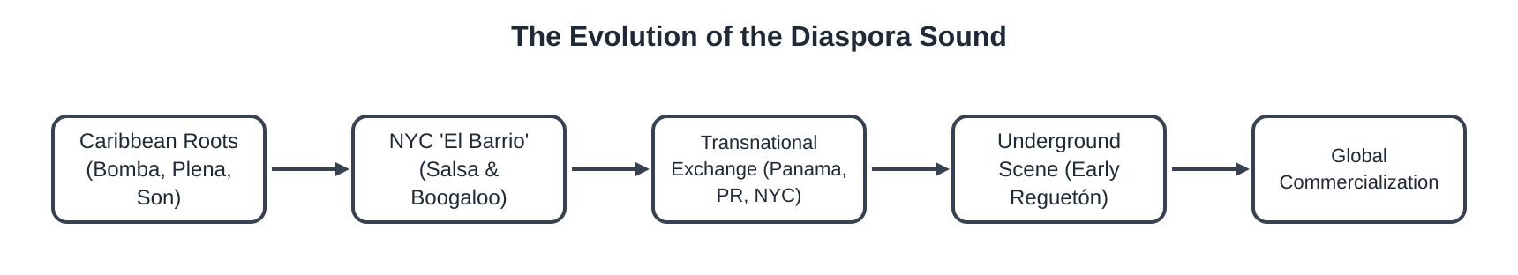
Trace the movement of musical influence across borders and eras. ( for teachers)

Mapping the Movement
Based on the text, identify which musical elements or influences traveled between these locations to create the 'Nuyorican' and 'Reguetón' sounds.
Influences from Panama and Jamaica included... while NYC contributed...

Critical Analysis: Marginalization & Commodification
1. Marginalization & Youth Culture  How does the 'underground' nature of early Reguetón reflect the social status of Puerto Rican youth in both the island and the diaspora? | 2. Commodification  'Commodification' occurs when a cultural expression is turned into a product for sale. What happens to the 'protest' or 'resistance' roots of music when it becomes a global commercial success?

Station Synthesis: Music as a Mirror
In what ways does the transition from Salsa to Reguetón mirror the changing geographic and social journey of the Puerto Rican people?

In this final task, you will synthesize everything you have learned from the four stations. You will analyze the direct connection between the economic policies that transformed Puerto Rico and the unique cultural identity that emerged in the diaspora through music.

AP-Style Argumentative Prompt: To what extent did economic policies in Puerto Rico shape the cultural identity of the Nuyorican diaspora?
Writing Checklist:
- Claim: Clearly state how much economic policy influenced identity.
- Evidence 1 (Economics): Reference Operation Bootstrap, the shift from agriculture (sugar/coffee), or displacement.
- Evidence 2 (Culture): Reference a specific musical genre (Bomba, Plena, Salsa, or Reguetón) as a 'cultural weapon' or reflection of the diaspora.
- Analysis: Explain the link between economic marginalization and the need for cultural resistance/expression.
- Vocabulary: Use at least two terms from your bank (e.g., diaspora, enclave, marginalization).
Economic policies in Puerto Rico, specifically Operation Bootstrap, significantly shaped the cultural identity of the Nuyorican diaspora by...

Self-Reflection: The 'Cultural Weapon'
Based on your analysis, why does music like Salsa or Reguetón remain such a powerful tool for youth facing marginalization today?

